The Project “BANK MODULE SYSTEM” is a typical bank management system which can be used in banks to offer various typical facilities in an easy & convenient manner . Banking consists of various different operations which needs to be handled in a secure way for maintaining user’s integrity .

* IMPORTANCE:

The banking sector was always deemed to be one of the most vital sectors for the economy to be able to function. Its importance as the “lifeblood” of economic activity, in collecting deposits and providing credits to states and people, households and businesses is undisputable.

In all economic systems, banks have the leading role in planning and implementing financial policy. The difference lies with prioritizing goals and their way of achievement. Based on the neo-liberal model, achieving greater profits by using all means is an end in itself, while in the socialistic systems bank operations also aim at improving economy in general and at satisfying social needs.

* Earlier Banking Practice:

Earlier banking was a very hectic task . For transferring even a small amount of money people had to wait for a long time in queues . Security was also of very moderate level . Peoples need to go to their dedicated branch for handling their all banking activities as they can’t access banking services from any other place .

1. Technology evolution:

The banking sector has embraced the use of technology to serve its client’s faster and also to do more with less. Emerging technologies have changed the banking industry from paper and branch based banks to digitized and networked banking services. Unlike before, broadband internet is cheap and it makes the transfer of data easy and first. Technology has changed the accounting and management system of all banks. And it is now changing the way how banks are delivering services to their customers. However this technology comes at a cost, implementing all this technology has been expensive but the rewards are limitless.

* E-banking : This enables the bank to deliver its services easily to its high end customers. To make the system user friendly to all clients, banks have used a Graphical User Interface (GUI)  with this software , customers can access their bank details on their own computers, make money transfers from one account to another, print  bank statements and  inquire about their financial transactions.
* Remote banking **:**  Banks have installed ATM machines in various areas; this means a customer does not have to go to the main branch to make transactions. This facility has also enabled anytime banking, because customers can use ATM machines to deposit money on their accounts. Remote banking has helped people in rural areas improve on their culture of saving money.
* WHY BANK MODULE :

Our aim is to develop a software for solving financial applications of a customer in a banking environment in order to nurture the needs of an end banking user by providing various effective ways to perform banking tasks .

This module helps in managing all the banking tasks in a centralized manner . Users can do all their banking tasks by themselves without needing any support . In this era of automation people wants a highly secure and easy to manage modules for their banking tasks because the confidentiality is of utmost importance .

Web-based banking systems use a dedicated server through a bank network system. An area of the banking system is partitioned for Internet applications. Web-based banking systems by law must include secure servers and authenticated certificates regarding transactions from the Federal Deposit Insurance Company and the Federal Reserve Board. Customers who choose to bank online can access their account through a web interface, which integrates with the main computer.



SOFTWARE’S USED

* NETBEANS IDE 6.5.1 : (FRONT - END)

NetBeans is an open-source integrated development environment (IDE) for developing with Java, PHP, C++, and other programming languages. NetBeans is also referred to as a platform of modular components used for developing Java desktop applications. NetBeans is coded in Java and runs on most operating systems with a Java Virtual Machine (JVM), including Solaris, Mac OS, and Linux.   
NetBeans manages the following platform features and components:

User settings

* Windows (placement, appearance, etc.)
* NetBeans Visual Library
* Storage
* Integrated development tools
* Framework wizard

NetBeans uses components, also known as modules, to enable software development. NetBeans dynamically installs modules and allows users to download updated features and digitally authenticated upgrades.   
NetBeans IDE modules include NetBeans Profiler, a Graphical User Interface (GUI) design tool, and NetBeans JavaScript Editor.  
NetBeans framework reusability simplifies Java Swing desktop application development, which provides platform extension capabilities to third-party developers.



* INTRODUCTION TO JAVA :

JAVA was developed by Sun Microsystems Inc in 1991, later acquired by Oracle Corporation. It was developed by James Gosling and Patrick Naughton. It is a simple programming language.  Writing, compiling and debugging a program is easy in java.  It helps to create modular programs and reusable code.

* PLATFORM INDEPENDENT : Unlike many other programming languages including C and C++ when Java is compiled, it is not compiled into platform *specific machine*, rather into platform independent byte code.
* JAVA VIRTUAL MACHINE :

Java was designed with a concept of ‘write once and run everywhere’. Java Virtual Machine plays the central role in this concept. The JVM is the environment in which Java programs execute. It is a software that is implemented on top of real hardware and operating system. When the source code (.java files) is compiled, it is translated into byte codes and then placed into (.class) files.

* Four principles of Object Oriented Programming :
* Abstraction
* Encapsulation
* Inheritance
* Polymorphism



* MYSQL COMMAND LINE CLIENT :

(BACK – END)

**MySQL** is an [open-source](https://en.wikipedia.org/wiki/Open-source) [relational database management system](https://en.wikipedia.org/wiki/Relational_database_management_system)(RDBMS). Its name is a combination of "My", the name of co-founder [Michael Widenius](https://en.wikipedia.org/wiki/Michael_Widenius)'s daughter, and "[SQL](https://en.wikipedia.org/wiki/SQL)", the abbreviation for [Structured Query Language](https://en.wikipedia.org/wiki/Structured_Query_Language). The MySQL development project has made its [source code](https://en.wikipedia.org/wiki/Source_code) available under the terms of the [GNU General Public License](https://en.wikipedia.org/wiki/GNU_General_Public_License), as well as under a variety of [proprietary](https://en.wikipedia.org/wiki/Proprietary_software) agreements. MySQL was owned and sponsored by a single [for-profit](https://en.wikipedia.org/wiki/Business) firm, the [Swedish](https://en.wikipedia.org/wiki/Sweden) company [MySQL AB](https://en.wikipedia.org/wiki/MySQL_AB), now owned by [Oracle Corporation](https://en.wikipedia.org/wiki/Oracle_Corporation). For proprietary use, several paid editions are available, and offer additional functionality.

* DATABASE MANAGEMENT SYSTEM :

 Database-management system (**DBMS**) is a computer-software application that interacts with end-users, other applications, and the database itself to capture and analyze data. A general-purpose  **DBMS** allows the definition, creation, querying, update, and administration of databases. **Database** is a collection of related data and data is a collection of facts and figures that can be processed to produce information. A **database management system** stores data in such a way that it becomes easier to retrieve, manipulate, and produce information . 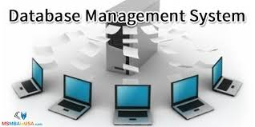 

* DATABASE CONNECTIVITY WITH NETBEANS

Step 1 – Import the packages required for database programming .

* import java.sql.Connection ;
* import java.sql.DriverManager ;
* import java.sql.Statement ;
* import java.sql.ResultSet ;

Step 2 – Add Mysql Connector in Library folder .

* Path (C/Program files/Ide/modules/ext/mysql.connector-java-5.1.18-bin)

Step 3 – Register JDBC Driver

* Class.forName(“java.sql.Driver”);

Step 4 – Open a Connection

Connection con = DriverManager.getConnection("jdbc:mysql://localhost:3306/" "root", "123");

Step 4 – Create a Statement

* Statement stmt = con.createStatement();

Step 5 – Create ResultSet

* ResultSet rs = stmt.executeQuery(x);

PROJECT OVERVIEW

Our Project Consists of 27 frames which gives effective functionality to users and manageability features to Manager and Accountant .

* LOADING FRAME – Provides Splash screen for loading necessary files & databases .
* WELCOME FRAME – Allows to choose a designation to enter with .
* MANAGER CONTROL : Manager can have following control
* SEE ALL ACCOUNTS
* CONTROL USERS
* LOAN APPLICATIONS
* USER FACILITIES : User get following facilities
* DEPOSIT & WITHDRAW MONEY
* APPLY FOR LOAN
* STATUS OF LOAN
* MONEY TRANSFER
* MOBILE RECHARGE
* LINK AADHAAR
* ACCOUNTANT FACILITIES : Accountant can see
* LOAN DETAILS
* TRANSACTIONS OF ANY ACCOUNT
* BANK MODULE DATABASE CONSISTS OF FOLLOWING TABLES FOR STORING DATA :
* ACCOUNT TABLE –
  + For storing all personal and account details of user .
* LOGIN TABLE -
  + For storing all login details including passwords .
* TRANSACTION TABLE –
  + For storing transaction details of each account .
* LOAN TABLE -
  + For storing all loan details .
* BALANCE TABLE -
  + For storing amount details of each account
* MANAGER TABLE -
  + For storing login details of manager .
* ACCOUNTANT TABLE -
  + For storing login details of accountant
* LOADING FRAME

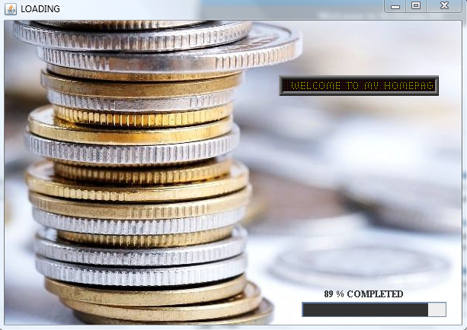

**Description** :

On starting the project firstly this splash screen comes which consists of a progress bar which indicates the progress of completion of all database files loading in background .

When the progress bar reaches 100% this frame closes automatically and the next frame opens . There is no need to create database manually it gets created automatically .

* WELCOME FRAME

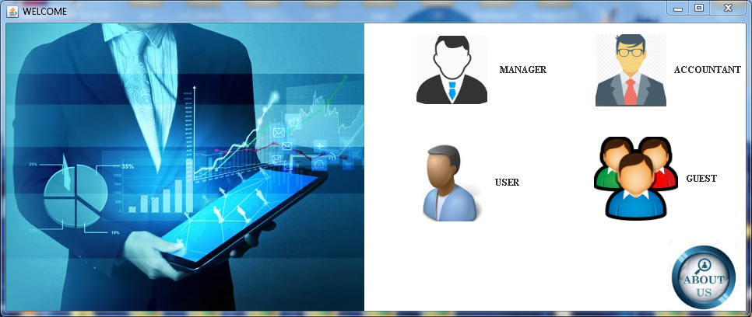

**Description** :

This frame contains 5 buttons which gives you a designation to enter with . It gives a separate domain for all the peoples a manager opens his tab and get access to all his provided facilities an accountant gets his own set of options to work on if user wants to enter then they had their own separate option if u r a guest and not a legimitate user then you get basic details about the bank if any persons opts for any possible options then this frame automatically closes and their selected option’s frame opens . It also contains about us tab to get details about the developers and guides .

MANAGER

* MANAGER-LOGIN FRAME

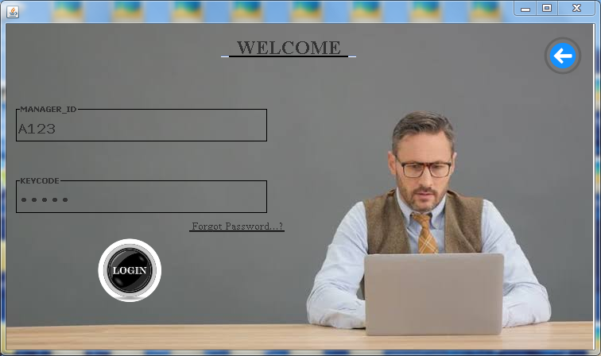

**Description** :

When manager enters he/she needs to log in with their unique Id & Keycode which is compared in the backend with the original Id & Keycode and if it matches then that person is given access to manager account . It also contains a Forgot Password option which gives a general hint in case a person forgot his password and that hint is set by manager itself . A Back button for navigating to previous frame .

* MANAGER-HOME FRAME

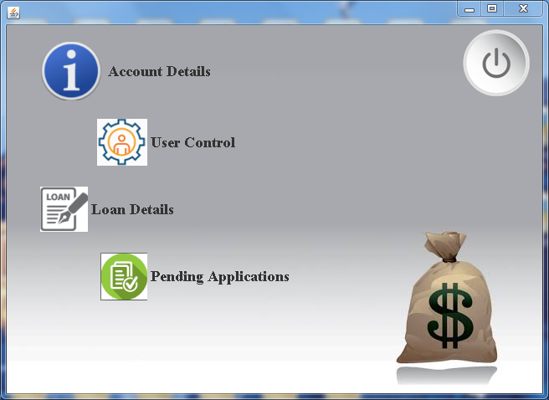

**Description** :

When manager LOGIN in his portal he get this frame which contains all the options for manager . It contains Account-Details button to get details of account’s, User –Control button to manipulate user details , Loan-Details button to get details about the loans given or rejected , Pending –Applications button to see all loan applications by users and accepting or rejecting those applications . It also contains a LOG OUT button to log off from account .

* ACCOUNT-DETAILS FRAME

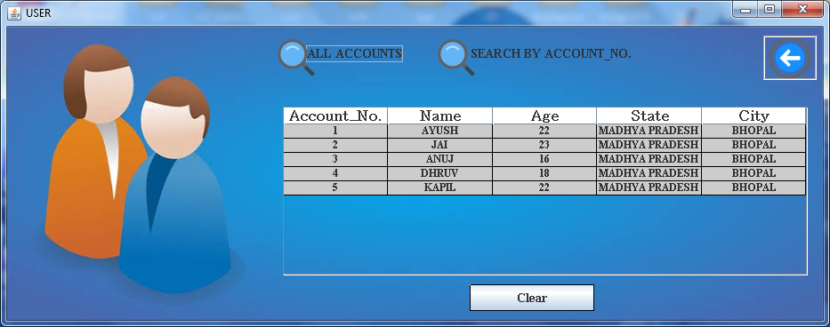

**Description** :

When manager clicks on account details he gets to see this frame in which he has two options to search account . If he clicks on ALL ACCOUNTS he gets details of all the account of the bank if he wants to search details of a specific account using account no. of account then he need to click SEARCH BY ACCOUNT NO in which he will enter the desired account no. and all details of only that particular account no are displayed .CLEAR button is used to clear entries from table & BACK button for going to previous screen .

* USER-CONTROL FRAME

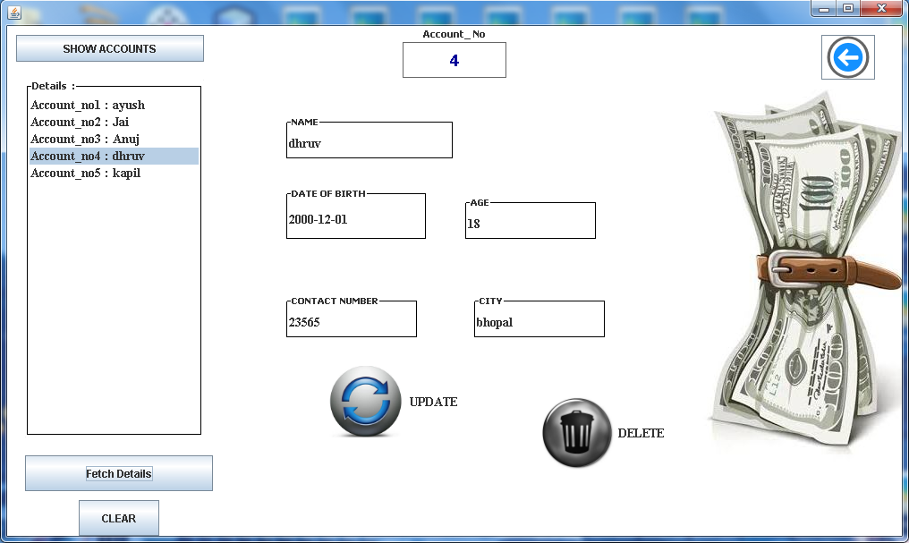

**Description** :

When manager clicks on user control then he gets this frame where he can see personal details(which are shared with bank) of any user .On clicking SHOW ACCOUNTS all the account no. are listed in list and on selecting the desired account no. from the liast its details can be fetched . Manager can make changes in details and can Update the account . Manager can also Delete an account if any discrepancy is found in account . Clear button clears the list and Back button is used to navigate to options page for manager .

* LOAN-DETAILS FRAME

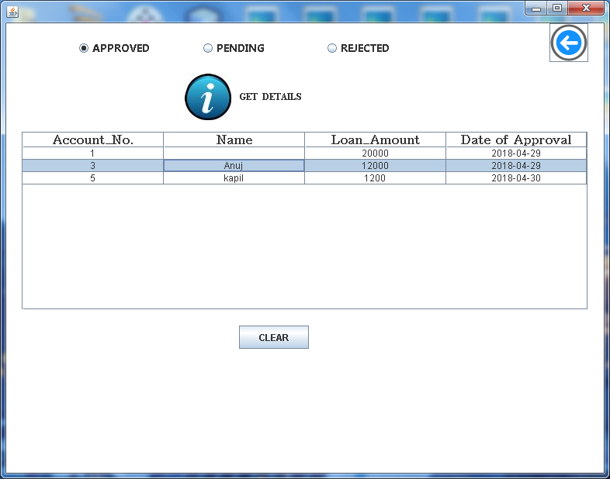

**Description** :

When manager clicks on loan details then he gets this frame in which by selecting the status of loan among APPROVED , PENDING or REJECTED . On clicking GET DETAILS all the accounts with selected status of loan gets listed in the table with Account no , Name & Loan Amount . If loan status is Approved then the date of approval also gets listed in table . Clear button clears the table enteries and Back button is used to navigate to options page for manager .

* PENDING - APPLICATIONS FRAME

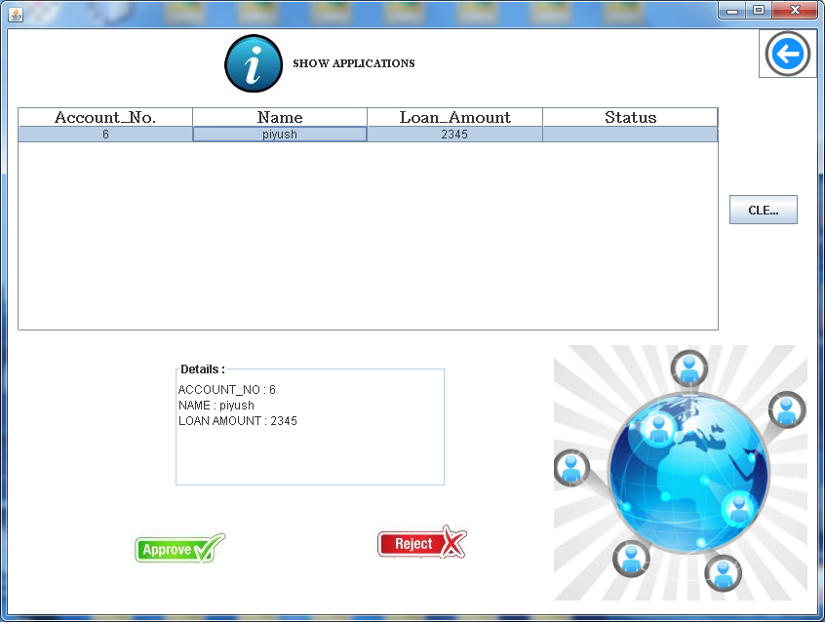

**Description** :

When manager clicks on Pending – Applications button he gets this window . On clicking SHOW APPLICATIONS he can see all the Loan Applications by the user , by selecting any entry from table their details got printed in Details area . Manager can Approve appropriate Application and can Reject any invalid Application . .Clear button clears the table enteries and Back button is used to navigate to options page for manager .

ACCOUNTANT

* ACCOUNTANT - LOGIN FRAME

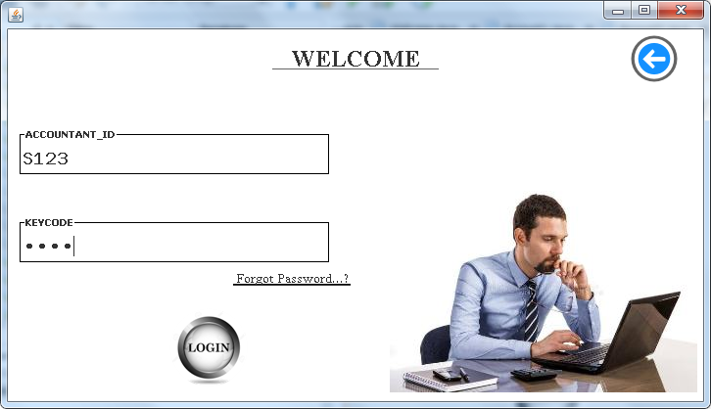

**Description** :

When accountant enters he/she needs to log in with their unique Id & Keycode which is compared in the backend with the original Id & Keycode and if it matches then that person is given access to accountant’s account . It also contains a Forgot Password option which gives a general hint in case a person forgot his password and that hint is set by accountant itself . A Back button for navigating to previous frame .

* ACCOUNTANT - HOME FRAME

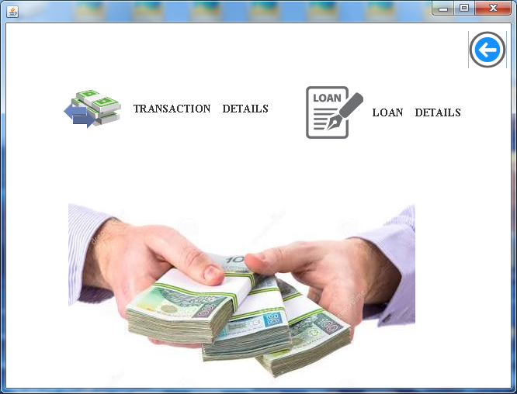

**Description** :

When accountant LOGIN in his portal he get this frame which contains all the options for accountant It contains Transaction-Details button to get details of Transaction of all the accounts , Loan-Details button to get details about the loans given or rejected . It also contains a LOG OUT button to log off from account . Accountant can only get to see the details but he cannot modify any details it is in under Managers’s control .

* TRANSACTION - DETAILS FRAME

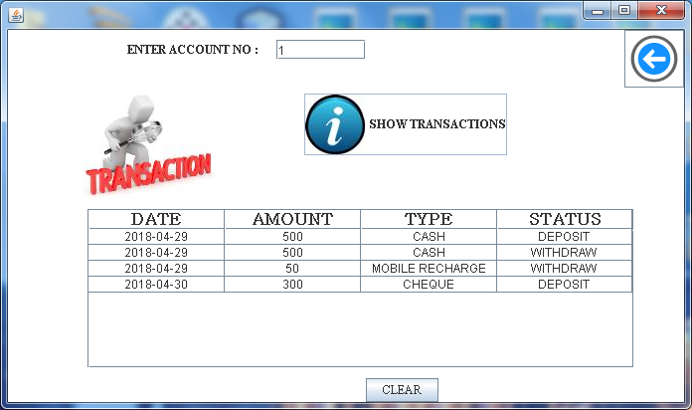

**Description** :

When accountant clicks on Transaction details button he gets this window . Desired account no. is entered then on clicking SHOW TRANSACTIONS he can see all the details of all the Transactions in that particular account including date of transaction , amount , type and status of transaction . Clear button clears the table enteries and Back button is used to navigate to options page for manager.

* LOAN-DETAILS FRAME

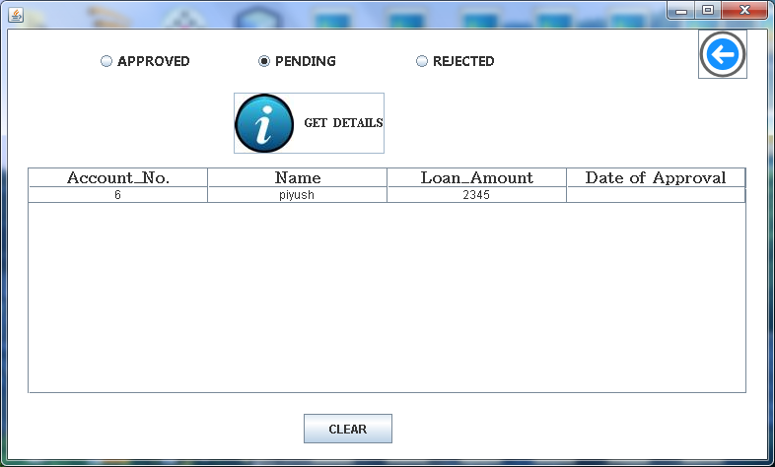

**Description** :

When accountant clicks on loan details then he gets this frame in which by selecting the status of loan among APPROVED , PENDING or REJECTED . On clicking GET DETAILS all the accounts with selected status of loan gets listed in the table with Account no , Name & Loan Amount . If loan status is Approved then the date of approval also gets listed in table . Clear button clears the table enteries and Back button is used to navigate to options page for accountant .

USER

* USER - LOGIN FRAME

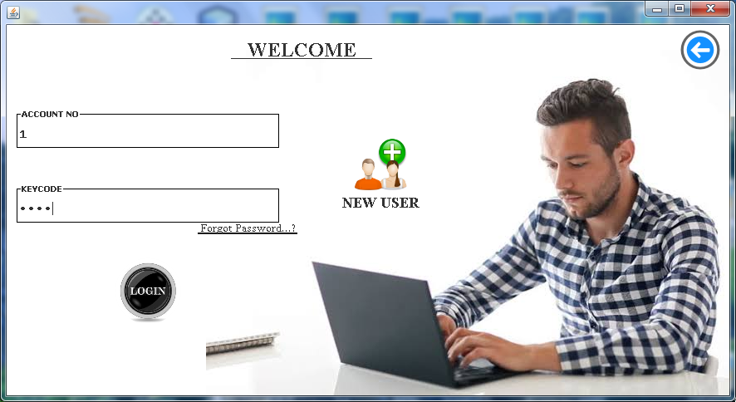

**Description** :

When User enters he/she needs to log in with their unique Account no. & Keycode which is compared in the backend with the Keycode associated with Account no. and if it matches then that person is given access to User’s account . It also contains a Forgot Password option which gives an option to Aadhaar Linked account holders to recreate their password by reconfirming their Aadhaar no. A New User button allows you to sign up and get an account in the bank . A Back button for navigating to previous frame .

* FORGOT PASSWORD FRAME

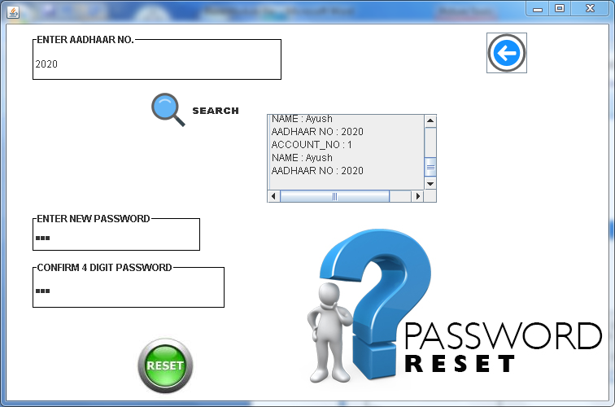

**Description** :

When User Forgot their password then they need to do manual verification by visiting branch , but if your account is linked with Aadhaar then you do not need to do any manual verification You will be able to recreate your password just by confirming your aadhaar no. A Back button for navigating to previous frame .

* ACCOUNT LOCK FRAME

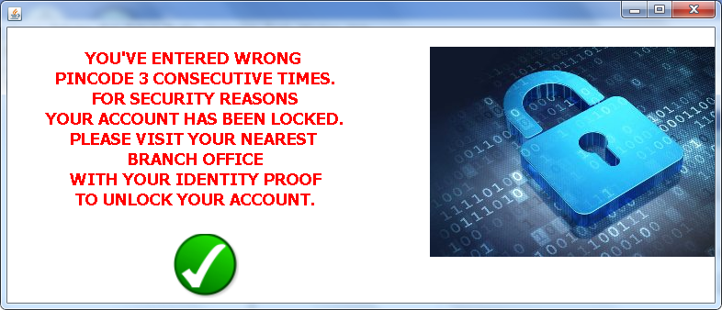

**Description** :

When User enters Wrong Password for more than 3 times consecutively then his account gets locked due to security reasons and cannot be accessed until personal verification in nearest branch office is done . User will not be able to access any of the services till the time account is locked . This ensures the security of users account from unauthorized access .

* NEW USER FRAME

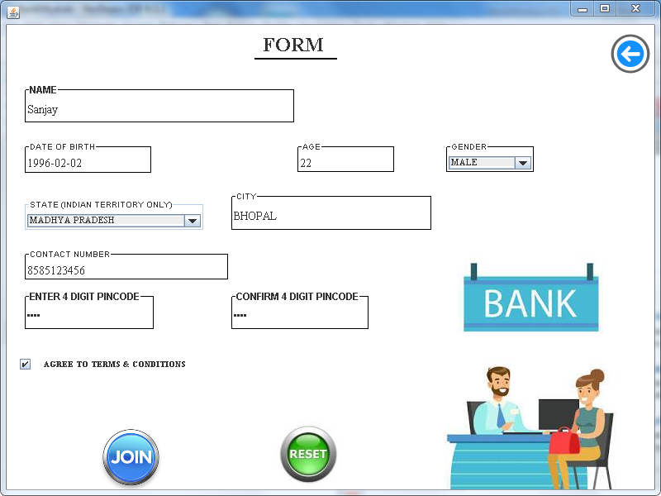

**Description** :

When any new user wants to get an account in the bank he needs to fill the form asking for his details which are required to ensure his identity . Details like Name , DOB , Age , City , Gender , Contactno , PIN needs to be entered . Only by agreeing to the terms one will be able to Join the bank and get an account . Account no. is automatically provided by bank and that is not user’s choice & every new user gets a welcome bonus of Rs 1000 in their account .

* USER - HOME FRAME

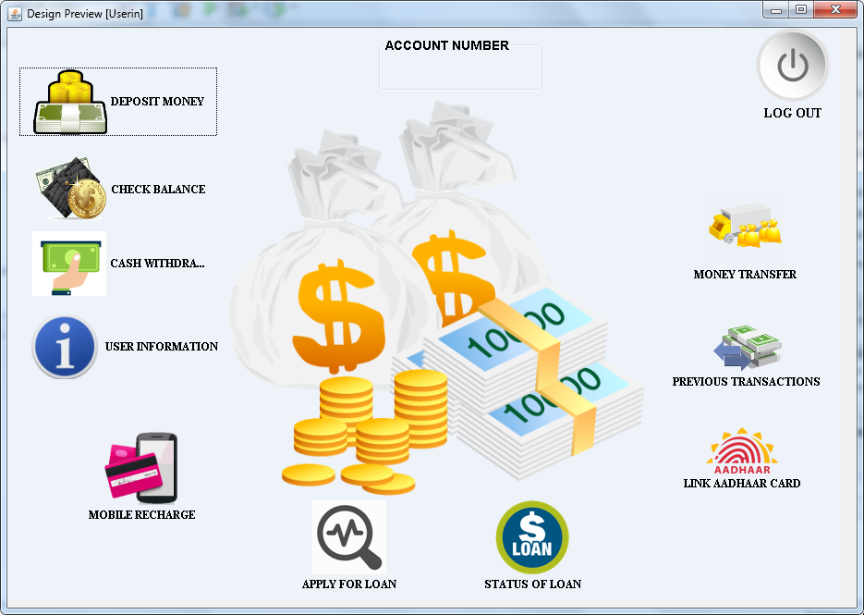

**Description** :

When user LOGIN in his portal he get this frame which contains all the options for user . A User will be able to deposit and withdraw money , Check his current balance , Can see his personal Info, Can Recharge a mobile , Transfer Money to Other Accounts , Link his Aadhaar card with the account , Can Apply for Loan and Check Loan Status , Monitor his Transactions .

* DEPOSIT MONEY FRAME

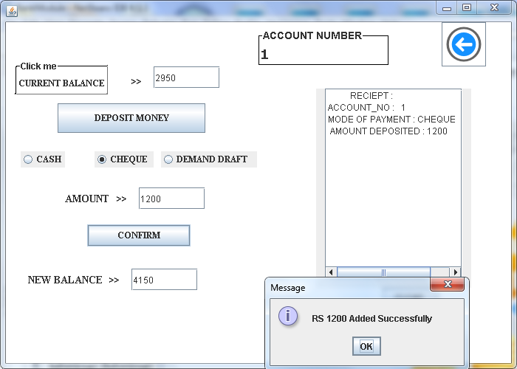

**Description** :

When user clicks on Deposit Money button he gets this frame in which firstly his current balance is calculated and then selecting any mode of payment from Cash, Cheque or Demand Draft the desired amount can be added . After successful deposition of money a receipt gets printed giving all details of deposition . Back button to get back to the User’s home screen .

* CHECK BALANCE FRAME

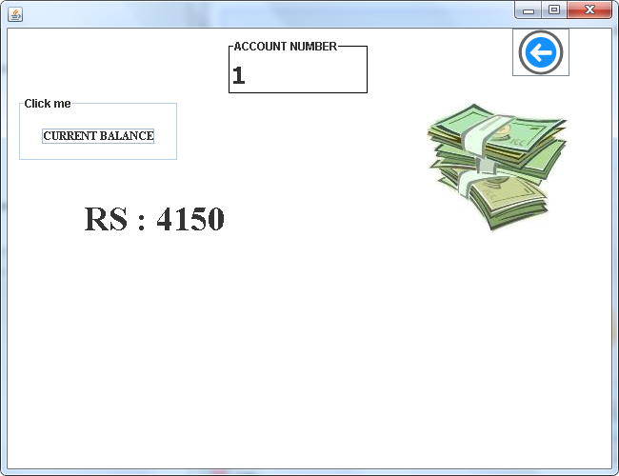

**Description** :

When user clicks on Check balance Button he gets this frame in this on clicking Current balance button user’s account Balance is displayed in static manner . Back button to get back to the User’s home screen .

* CASH WITHDRAWL FRAME

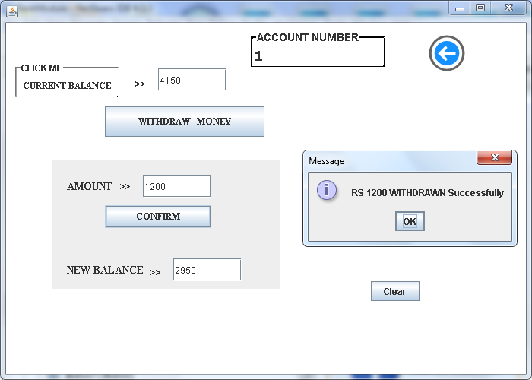

**Description** :

When user clicks on Cash Withdraw button he gets this frame in which firstly his current balance is calculated and then desired amount (less than balance) can be withdrawn . After successful withdrawl of money a receipt gets printed giving all details of this transaction . Back button to get back to the User’s home screen .

* USER - INFO FRAME

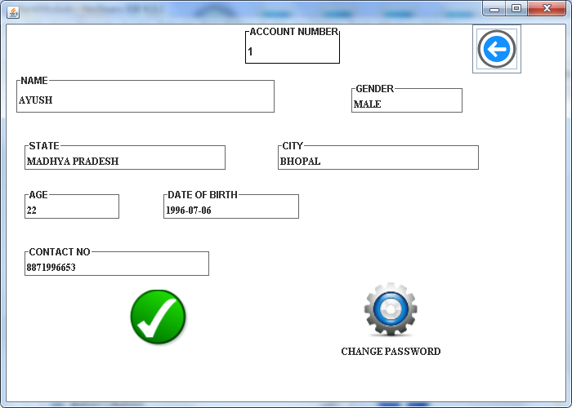

**Description** :

When user clicks on User Info he gets this frame in which all his details are shown which he had entered at the time of sign up but the details are in a static form i.e. it can’t be modified . Details like Name , DOB , Age , City , Gender , Contactno are shown .

It contains a Change Password button which allows a user to change his current password . Back button to get back to the User’s home screen .

* CHANGE PASSWORD FRAME

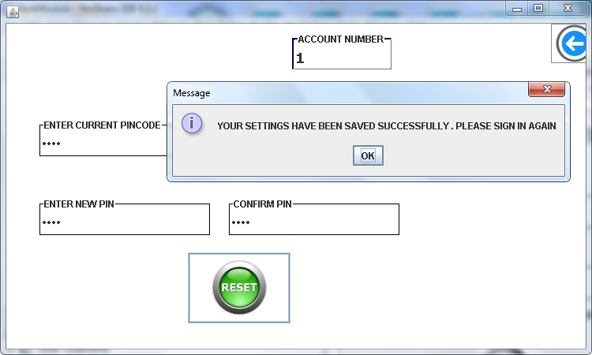

**Description** :

When user clicks on Change Password this screen gets visible . In this user needs to add their current password for authentication and then user can recreate their password .

Back button to get back to the User’s home screen .

* MOBILE - RECHARGE FRAME

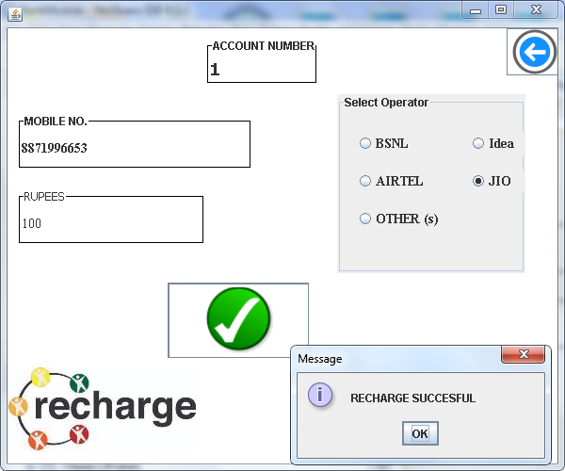

**Description** :

When user clicks on Mobile Recharge then this frame gets visible . User needs to add their mobile no. & Recharge amount then select their Operator from available Operators . Back button to get back to the User’s home screen .

* APPLY FOR LOAN FRAME

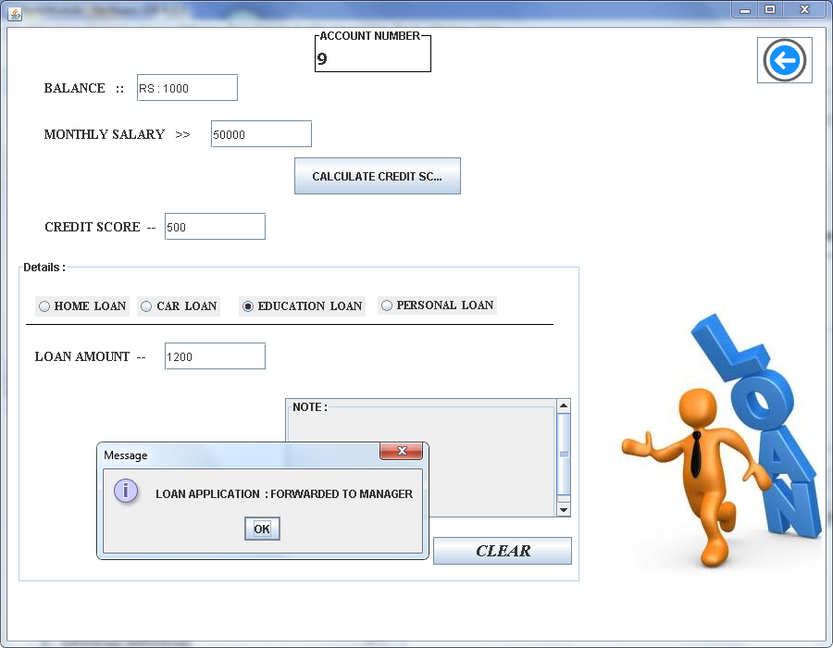

**Description** :

When user clicks on Apply Loan then this frame gets visible . Balance of account is automatically calculated and show . User needs to add their Monthly Salary based on which their credit score is calculated which decides that user is eligible for loan or not . If monthly salary is less than Rs10000 then calculated credit score becomes less than 500 which makes user not eligible for loan .

If Credit Score equals 500 then user is eligible for loan he needs to choose type of loan from Home,Car ,Education or Personal . Maximum limit of loans are Rs 20,00,000 for HOME , Rs 5,00,000 for CAR , Rs 15,00,000 for EDUCATION , RS 4,00,000 for PERSONAL LOANS.

User needs to enter loan amount within above mentioned values. If loan criteria is matched then your Application of loan gets Forwarded to Manager and a Reciept gets printed giving details .

* STATUS OF LOAN

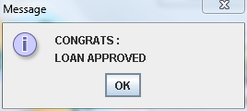

* Once Applied for Loan User can track his loan status .
* MONEY TRANSFER FRAME

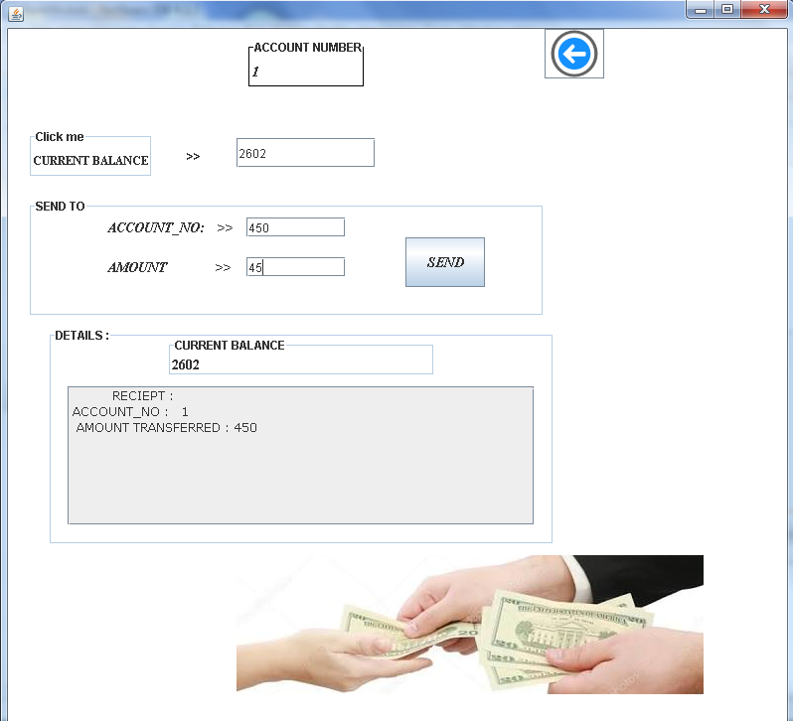

**Description** :

When user clicks on Money Transfer then this frame gets visible . Balance of account is calculated then details of receiver are filled which includes account no. of receiver & Amount to be transferred. After successful transfer of money remaining balance is shown and a receipt got printed giving details of current transaction . . Back button to get back to the User’s home screen

* PREVIOUS TRANSACTIONS FRAME

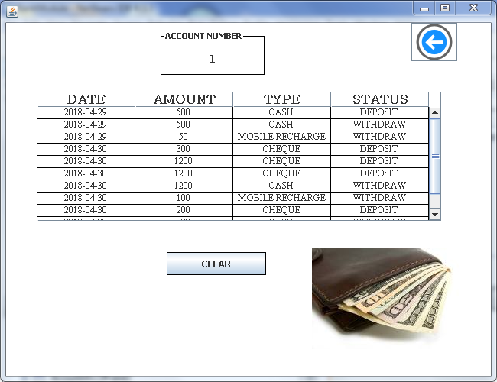

**Description** :

When user clicks on Previous Transactions then this frame gets visible . All the transactions from the account gets listed in the table with details like Date , Type & Amount . Back button to get back to the User’s home screen .

* LINK AADHAAR FRAME

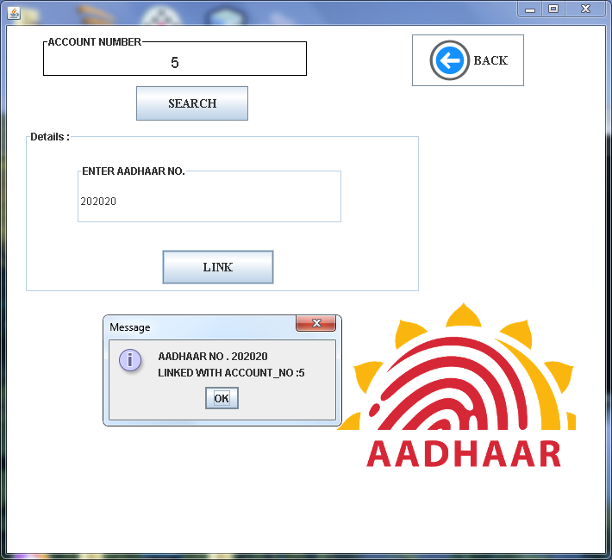

**Description** :

When user clicks on Link Aadhaar then this frame gets visible . Firstly it searches that given account is linked with aadhaar or not , if not then user needs to enter his Aadhaar no . which gets linked to your account . In case user forgot his password at that time if their aadhaar is linked then they will be able to recreate the password without any manual verification .

GUEST

* GUEST FRAME

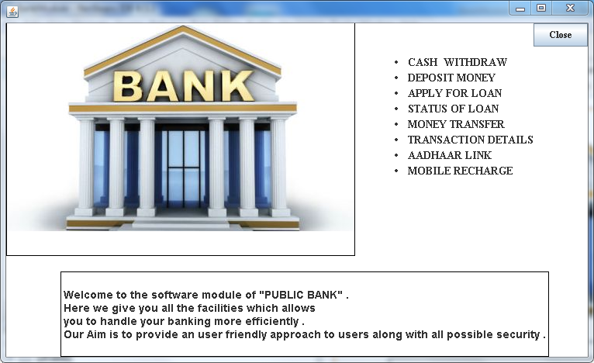

**Description** :

When any Guest who do not have account wants to know about the bank then this static page gives all details for them to know all basic information about bank along with services provided by bank .

ABOUT US

* ABOUT US FRAME

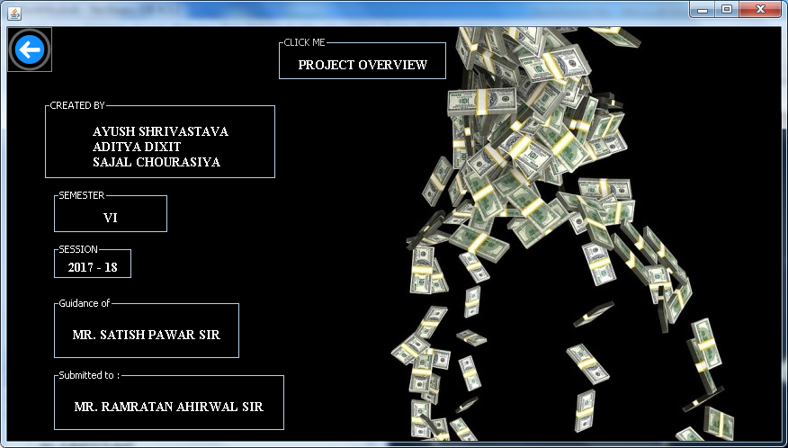

* This frame gives all the details about the hands behind the creation of this module .
* GUIDE TO PROJECT FRAME

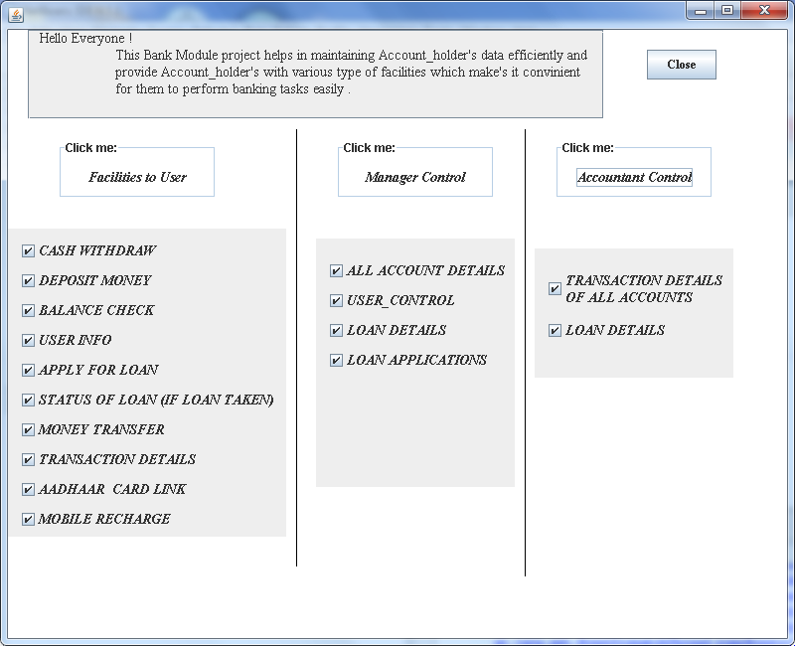

* It gives a Synopsis of functionality of project .

SQL QUERIES :

* Create table Manager (Id varchar(5),password varchar(20),name varchar(10));
* Create table Accountant (Id varchar(5),password varchar(20),name varchar(10));
* Create table Account (accountno int(5) primary key,name varchar(30),gender varchar(6),age int(3),dob date,state varchar(30),city varchar(20),contactno mediumtext);
* Create table Balance (accountno int(5),balance int(10));
* Create table Login (accountno int(5),password int(4),status varchar(10),name varchar(30),aadharno varchar(10) default 'NOT LINKED');
* Create table Transaction (accountno varchar(5),type varchar(20),dot date,amt int(6),num varchar(20));
* Create table Loan (accountno varchar(5),name varchar(50),dot date,status varchar(20) default 'NOT APPLIED',amount int(10) default '0' );